­­­WRSPM

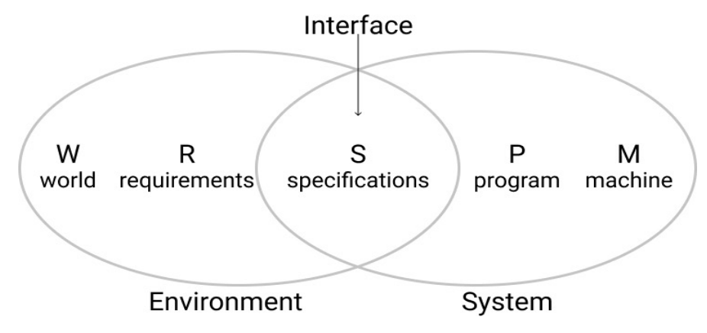

Prompt

There are **three** users in this system- admin, faculty, and the students. The faculty and students have to register themselves before using the system and the **admin’s** role is just to maintain all registered users. The faculty will upload the necessary study materials and assignments related to his/her subject and the students can read the study materials. This will reduce the paperwork and wastage of time for teachers and students.

W — is the world assumptions, that we know are true. They have an impact on our system and on our problem domain. These things everyone takes for granted, and they are one of the most difficult parts to capture.

R — is the requirements. This is the **user’s** language understanding of what the user wants from the solution. For example, users want to withdraw money. The ATM is the solution.

S—is the specification. It is the interface between how the system will meet those requirements. It is written in system language that says in plain English what the system will do. The specification is how the system meets the requirements. For example, in order to withdraw money from the ATM, you have to insert your card, insert PIN-number, etc. Those are the things user doesn’t care about. The user wants to get money.

P—is the program. It is what software developments will write. The program will meet the specifications to provide the user goal for requirements. The program has all the code, underlying frameworks, etc.

M—the machine. It is the hardware specification. For example, it includes the roller for distributing money, the lock box etc.

### World

* Our clients are involved in the school
* The number of people registered in the system will grow over time

### Requirements

* The user wants to register and maintain users
* An administrator needs to be able to manage all registered users
* Faculty and students should be able to register themselves
* Faculty must be able to upload materials relevant to their subject/class
* Students want to be able to access materials that are uploaded

### Specifications

* The User wants the system to have a document viewer
* The User wants the system to be secure
* The User wants the system to have standard features like account recovery and password reset
* There must be 3 different access levels for the system
* To register, a user must provide a username and password
* To upload documents, a button must be pressed, which will allow the user to attach a document of their choosing
* To view a document, the student must go to the professor’s course, and click on the document they wish to view

### Program

* A program which will be written in Python and have different segments for each major area of the project. This includes:
  + 3 distinct user levels. Student, Faculty, and Admin
  + A registering interface for Students and Faculty
  + An interface to upload and view documents

### Machines

* Any machine that can access a browser and connect to the database with an internet connection.